Planning Go-Ahead For Alty’s Community Sports Hall

Altrincham Football Club has been granted planning permission to build a community sports hall following overwhelming support from councillors and local residents.

The next challenge for the club is to secure financing for the project. The Robins recently set-up a non-profit company and are now in the process of applying to the Premier League and other organisations for funding.

The cost of the development is expected to be in the region of £750,000 with the club expected to raise around £200,000 from fund-raising activities and sponsorship.

The hall will host after-school clubs, disabled groups, ballroom dancing and sports such as yoga, martial arts, indoor bowls and badminton. The project is part of Alty’s London 2012 Olympic legacy.

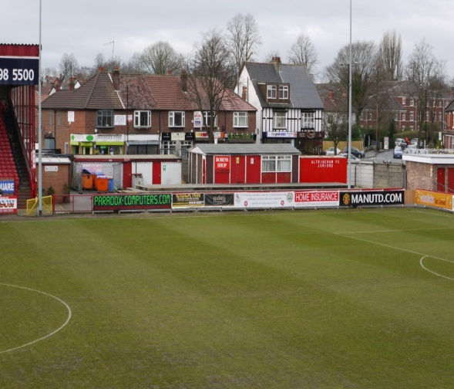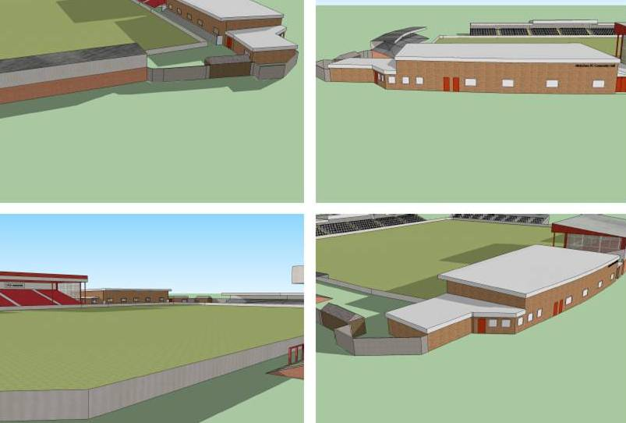

Chairman Grahame Rowley said: “We want to provide a facility that benefits the whole town and gets people of all ages active and involved in sport, not just football.

“The hall will provide a real community hub, but to make it happen we need local people and businesses to help. We will have a great facility here and we want it to serve the community, not just on match day.

“We have some fantastic sponsorship opportunities and events planned, so please get involved!”

Altrincham supporters and members of the community can be part of this legacy building by sponsoring the community sports hall.

Options include:

Donate £1,000 or more to the project and be recognised as a GIANTKILLER on our glass honours board. Local companies and partner organisations can donate £250 towards the project and have their logo displayed on our ‘Band of Community Businesses’ within the Sports Hall (30 x 15 inches per donation).

Donate £50 or more and be recognised as a Community Supporter on our glass honours board.

ENDS

Notes:

Altrincham FC has been based at Moss Lane for more than a century
The club runs a variety of community programmes and supports 37 junior football teams
The Community Sports Hall will be used by young people, the elderly, and disabled groups
The hall will be suitable for many sports including minority sports
The hall will be available for local sports clubs and schools
The hall will provide a facility for seminars, workshops, and local health/wellbeing groups
The hall will be used by the club on Match-days

The Sport Business CIC has been taken on by Altrincham FC to oversee fundraising and communications for the proposed development

The Sport Business is a Sale-based social enterprise www.thesportbusiness.co.uk
For more details contact: 0161 969 2242 / 07968 326541 info@thesportbusiness.co.uk

